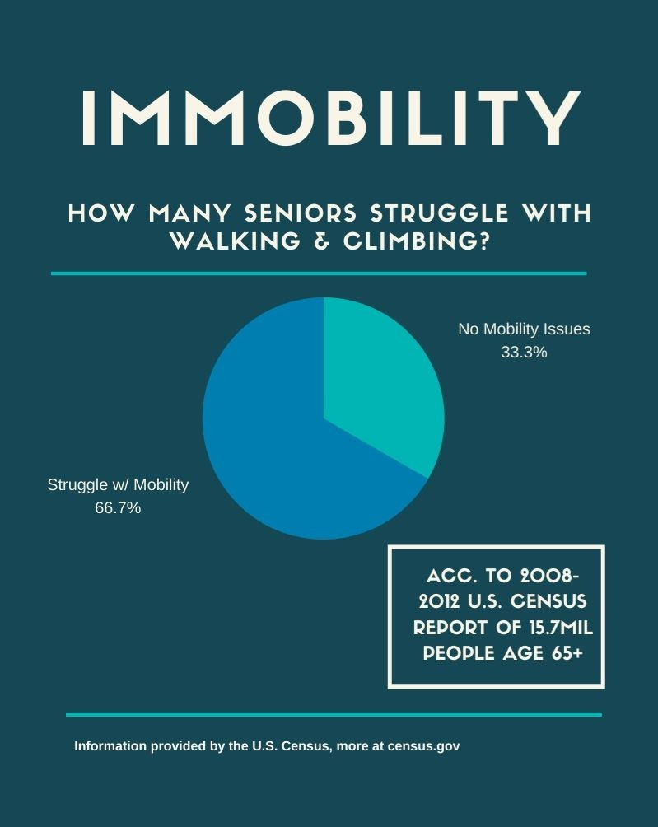

Immobility is one of the most common age-related disabilities. In a [report based on 2008-2012 U.S. Census results](https://www.census.gov/newsroom/press-releases/2014/cb14-218.html), it was determined that 2 out of 3 Americans age 65 and older struggle with walking and/or climbing.

It is a well-known fact that a large percentage of the aged adult population suffers from some level of mobility issues. The mobility issues may come in different forms from a little balance issue making it difficult for them to walk around to total immobility keeping your elderly client confined to the bed or a wheelchair.

**What causes sudden loss of mobility in elderly?**

Mobility problems may be unsteadiness while walking, difficulty getting in and out of a chair, or falls. There are common conditions in older people that can contribute to mobility problems, such as muscle weakness, joint problems, pain, disease, and neurological (brain and nervous system) difficulties.

**What causes immobility in the elderly?**

Arthritis, osteoporosis, hip fracture, stroke and Parkinson'sdisease are among the most common causes of immobility in old age. Complications of immobility such as orthostatic hypotension may occur in the dental patient.

**How does immobility affect the elderly?**

In addition to deconditioning, prolonged immobility is associated with increased fatigue, low self-esteem and loss of confidence. This can increase the risk of falls and the development of pressure ulcers. Mobility is important because it helps to maintain health and the body's ability to heal and repair.

**What patient findings with immobility issues?**

Patients who have mobility trouble are at risk for skin breakdown, ulcers, circulation, atrophy, constipation, and joint stiffness among other complications.

**What is the most common complication of immobility?**

Deep-vein thrombosis (DVT) is a common complication for clients experiencing immobility. When blood is not moving much due to client inactivity, it can coagulate (i.e, form a clot).

**Can immobility cause dementia?**

However, the mind also becomes affected by a body not in motion. As one sits idle or is confined to a bed or wheelchair, cognitive, psychological, and sensory problems like dementia, depression, fear and anxiety and impaired vision could become issues since the mind isn't being engaged.

**What are the neurological effects of immobility?**

Decrease in sensory stimulation due to lack of activity and altered sleep-wake pattern. Increased risk of depression, which may cause the patient to become apathetic, possibly because of decreased sensory stimulation; or the patient may exhibit altered thought processes.

**How can I help a patient with mobility issues?**

**Here are the ways you can assist patients with mobility issues.**

1. Promote Good Grooming and Hygiene. ...
2. Prevent Bedsores. ...
3. Change Bed Linens Regularly. ...
4. Ensure Good Nutrition. ...
5. Craft a Comfortable Environment. ...
6. Employ Patience and Empathy. ...